TEAM ID:PNT2022TMID4204



KEERTHI

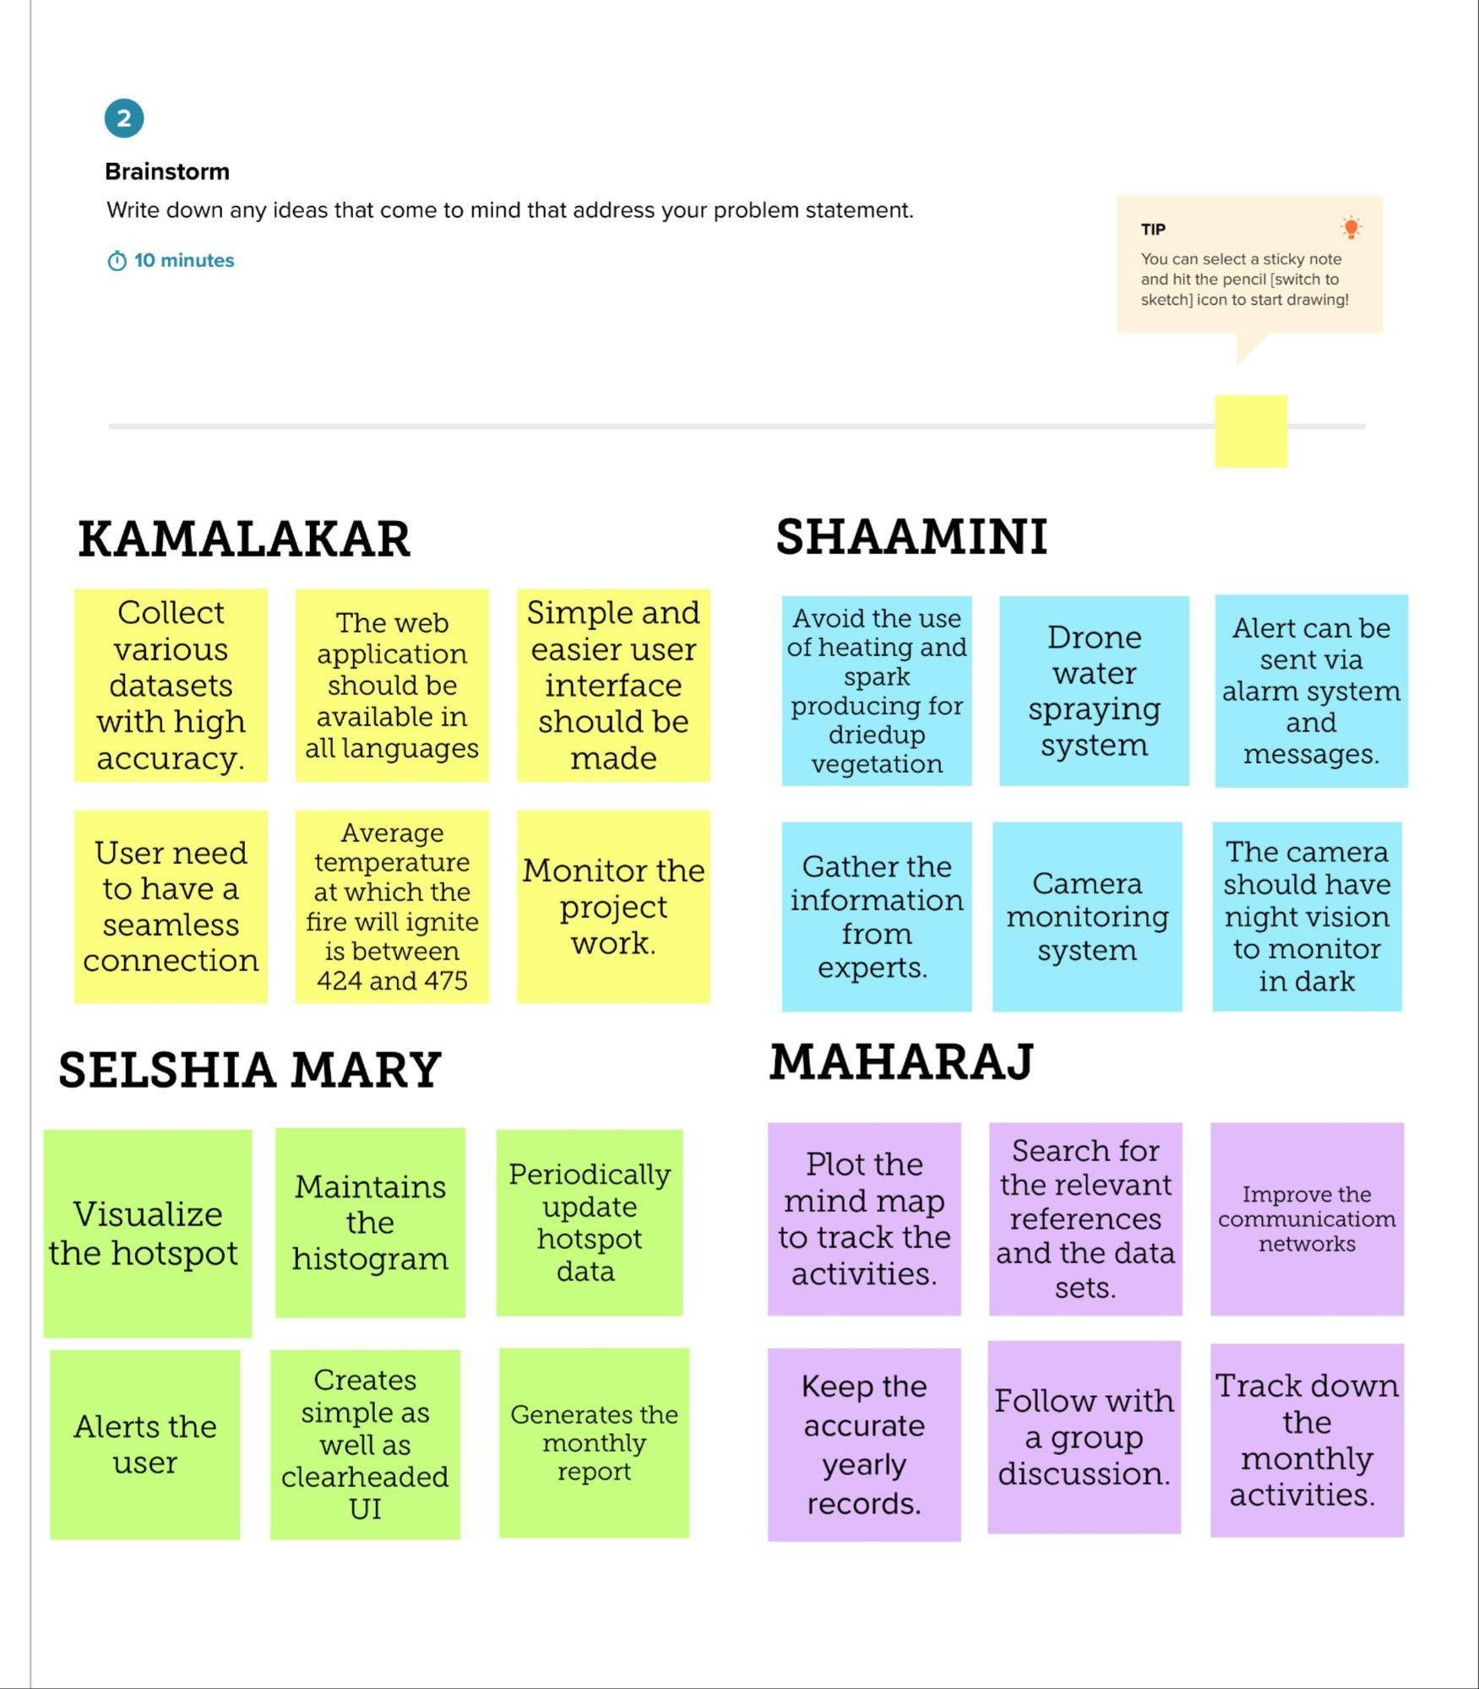

KALAISELVAN

KOKILAVATHI DHATCHANA

